New Student or Sibling
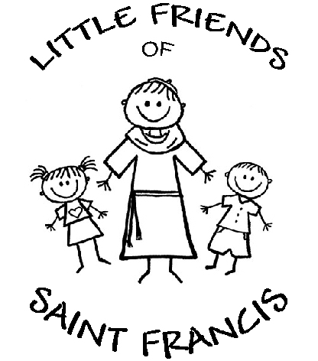
Date received: _____________________
Reg Fee-
Registration
If your child is the sibling of a current or former student, please list name(s) below:

______________________________________
2025-2026

ENROLLMENT IS GRANTED WITHOUT DISCRIMINATION IN REGARD TO SEX, RACE, RELIGION, OR POLITICAL BELIEF.

Child’s name _______________________________________________________________________________ M F

Child’s Date of Birth___________________________________________________ Age as of Sept. 1, 2025_____________

Mother’s name ___________________________________Father’s name__________________________________________

Mom Cell# __________________________________ Dad Cell#_____________________________________

E-mail address________________________________________________________________________________________

Siblings also registering ________________________________________________Sibling’s Age (as of 9/1/25) __________

Are you a tithing member of St. Francis Church? YES NO Date you joined the parish _____________

Has your child attended another program? YES NO If yes, where? __________________________________________

. ***Please note: Due to space limitations, some classes may have to be held in a different room on one day per week***
Please number the sessions in the order you would prefer:

2 year olds _____ W/F _____ M/T/TH _____ T thru F

3 year olds _____ T/TH _____ M/W/F _____ M/T/TH
_____ M thru Th _____ F (in addition to another session)

4 year olds _____ M/W/F _____ T thru F _____ M thru F

Transitional Kindergarten – Priority given to children turning 5 before Dec. 31, 2025

_____ M thru F

AFTER YOU RECEIVE CONFIRMATION OF YOUR CHILD’S PLACEMENT, A NON-REFUNDABLE REGISTRATION FEE OF $150 MUST BE PAID TO THE PRESCHOOL OFFICE WITHIN ONE WEEK.
FAILURE TO PAY BY THIS DATE FORFEITS YOUR CHILD’S SPACE IN OUR PROGRAM.

Session offered: ______________________________________________________

Mother

I am involved in the following ministries at St. Francis:

Ministry

1. ____________________________________________________________________________________

2. ____________________________________________________________________________________

3. ____________________________________________________________________________________

4. ____________________________________________________________________________________

I have volunteered at the church for the following projects or for the following person:

______________________________________________________________________________________

______________________________________________________________________________________

______________________________________________________________________________________

Father

I am involved in the following ministries at St. Francis:

Ministry

1. ____________________________________________________________________________________

2. ____________________________________________________________________________________

3. ____________________________________________________________________________________

4. ____________________________________________________________________________________

I have volunteered at the church for the following projects or for the following person:

______________________________________________________________________________________

______________________________________________________________________________________

______________________________________________________________________________________

